Feminine Rhyme (Double Rhyme)

🔹 What is Feminine Rhyme (Double Rhyme)
# Source: Chatgpt (GPT-4-turbo) at [8/2/2025]
⚠️ Like “masculine rhyme,” feminine rhyme is a type of poetic rhyme, not a type of homograph, but homographs can appear in such rhymes if their pronunciation fits.

✅ Definition of Feminine Rhyme
# Source: Chatgpt (GPT-4-turbo) at [8/2/2025]
A feminine rhyme (also called a double rhyme) occurs when two or more syllables rhyme, with the first syllable stressed and the next one(s) unstressed.
It creates a softer, more musical effect compared to the sharpness of masculine rhyme.

🧠 Key Features
# Source: Chatgpt (GPT-4-turbo) at [8/2/2025]
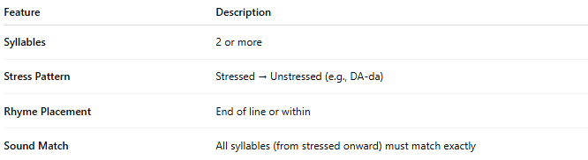
Feature | Description
Syllables | 2 or more
Stress Pattern | Stressed → Unstressed (e.g., DA-da)
Rhyme Placement | End of line or within
Sound Match | All syllables (from stressed onward) must match exactly

📝 Examples of Feminine Rhymes
# Source: Chatgpt (GPT-4-turbo) at [8/2/2025]
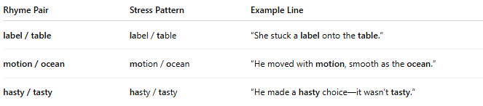
Rhyme Pair | Stress Pattern | Example Line
label / table | label / table | “She stuck a label onto the table.”
motion / ocean | motion / ocean | “He moved with motion, smooth as the ocean.”
hasty / tasty | hasty / tasty | “He made a hasty choice—it wasn’t tasty.”

🧪 Examples Using Homographs
# Source: Chatgpt (GPT-4-turbo) at [8/2/2025]
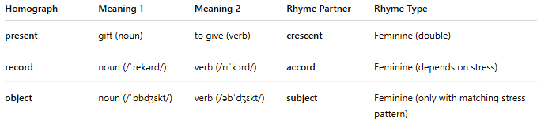
Homograph | Meaning 1 | Meaning 2 | Rhyme Partner | Rhyme Type
present | gift (noun) | to give (verb) | crescent | Feminine (double)
record | noun (/ˈrekərd/) | verb (/rɪˈkɔrd/) | accord | Feminine (depends on stress)
object | noun (/ˈɒbdʒɛkt/) | verb (/əbˈdʒɛkt/) | subject | Feminine (only with matching stress pattern)
⚠ Homographs only participate in feminine rhyme when the syllable stress and sounds match exactly from the stressed syllable onward.

📊 Masculine vs Feminine Rhyme
# Source: Chatgpt (GPT-4-turbo) at [8/2/2025]
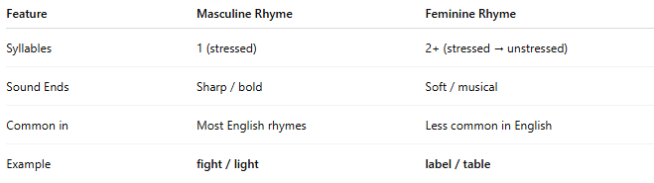
Feature | Masculine Rhyme | Feminine Rhyme
Syllables | 1 (stressed) | 2+ (stressed → unstressed)
Sound Ends | Sharp / bold | Soft / musical
Common in | Most English rhymes | Less common in English
Example | fight / light | label / table

✅ Summary
# Source: Chatgpt (GPT-4-turbo) at [8/2/2025]
- Feminine rhyme involves two or more syllables, beginning with a stressed one.
- Homographs can participate in feminine rhyme only when:
  - The syllable stress matches
  - The pronunciation fits exactly from the stressed syllable onward

